

Asset Practice Questions: Science

**1. Which of these is a food item?**

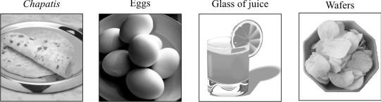

**A.** Only chapatis

**B.** Only chapatis and eggs

**C.** Only chapatis, eggs and wafers

**D.** All - chapatis, eggs, glass of juice and wafers

**2. Mohit wrote two words 'BED' and 'MAN' on a drawing board. He held the board in front of the mirror and looked at the words. They looked different. This is what they looked like.**

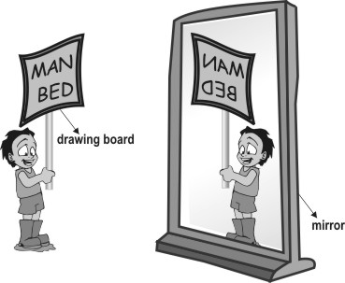

**Which of the following words given below will look the same on both the drawing board and the mirror?**

**A.** HIM

**B.** POT **C.** MOM **D.** SUN

**3. In the picture shown below, in which of the places (A, B, C or D) is it NIGHT?**

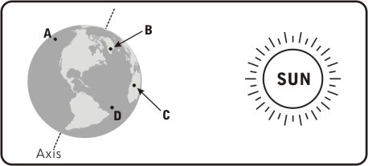

**4. Gautum's mother asked him to wash his hands before eating food to remove the germs in his hands.**

**Under which of the following circumstances should he also wash his hands?**

**A.** Cleaning his cycle

**B.** Taking off his shoes

**C.** Watering plants in his garden

**D.** Putting medicine on the wound on his knee

**5. Given below is a picture of India taken from very high up in the sky.**

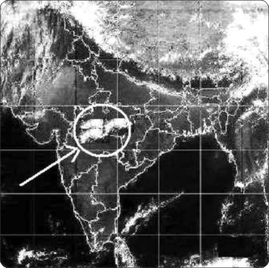

**What is the white part circled in the picture?**

**A.** Air

**B.** Soil

**C.** Clouds

**D.** Ocean

**6. Divya saw tiny things floating in the beam of sunlight that entered the room. What are these tiny things?**

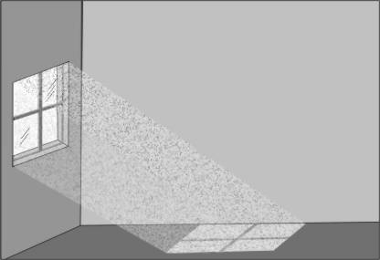

**A.** Particles of air

**B.** Particles of dust

**C.** Particles of water

**D.** Particles of sunlight

**7**. **A support is given for some types of jasmine plants but not for a hibiscus plant. This is because**

**_________.**

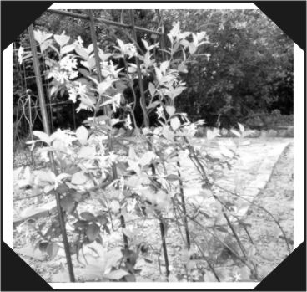

**A.** animals are attracted to some jasmine plants and the support helps to protect it from animals

**B.** only a jasmine plant has flowers because of which it needs a support

**C.** some jasmine flowers smell very good and the support helps to protect them from insects

**D.** some jasmine plants have weak stems while hibiscus plants have strong stems

**8. In India, the Sun rises in the East and sets in the West. In America, in which direction does the Sun rise and set?**

**A.** It rises in the East and sets in the West.

**B.** It rises in the West and sets in the East.

**C.** It both rises and sets in the West.

**D.** It both rises and sets in the East.

**9. Why do we usually not see the Moon during the daytime?**

**A.** Because thick clouds cover it.

**B.** Because of the bright sunlight.

**C.** Because the Moon is there only at night.

**D.** Because the Moon is on the other side of the Earth.

**10.** **In the picture given below, the** **potter is making pots. What material does he use to make pots?**

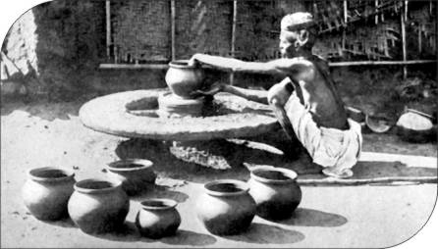

**A.** Clay

**B.** Sand

**C.** Cement

**D.** Bricks

**11. Braille is a special form of writing that blind people can read. Which of these senses do blind people use to read the Braille script?**

**A.** Taste **B.** Touch **C.** Smell

**D.** Hearing

**12. Which of the following was invented the last?**

**A.** Calculator

**B.** Typewriter

**C.** Laptop

**D.** Watch